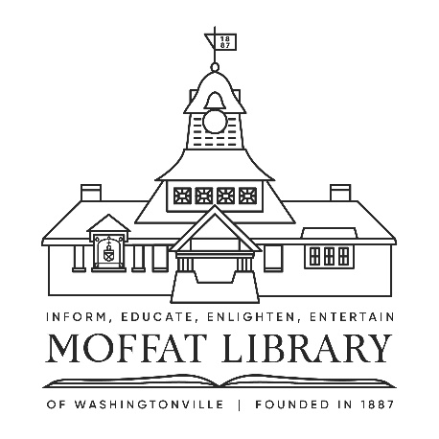
JOB OPENING
AT MOFFAT LIBRARY OF WASHINGTONVILLE
Part Time Information Specialists

Looking for a friendly and collaborative environment to work in? Then please keep reading. The Moffat Library of Washingtonville, a recently-renovated and expanded public library located in Orange County, New York, and serving a population of 25,208 residents, is seeking individuals to join our team as part-time Information Specialists working primarily at our Adult reference desk with occasional Children’s & Teens desk shifts.

Hours: Daytime shifts, evening shifts & weekend shifts for up to 20 hours per week. The library is open Monday-Thursday 10am-8pm; Friday 10am-6pm; Saturday 10am-5pm; & Sunday 12-5pm.

This position requires: strong customer service skills; flexibility; a positive attitude; an understanding and ability to work with people of all ages; knowledge of children’s, teen, and adult literature; and a good working knowledge of and comfort with current technology and trends. Experience in performing reference, reader's advisory, and digital instruction for multiple age groups is a plus.
Requirements: Candidates must possess MLS/MLIS degree + NYS Public Librarian's Certificate at the time of appointment. However, we are willing to train the right person and encourage MLIS students to apply.

Moffat Library is an equal opportunity employer.

STARTING SALARY: $20.00/hour (for MLIS students) - $23.00/hour (for individual w/ MLS/MLIS degree)
BENEFITS: NYS Retirement System (optional)

Continuously accepting applications. Interested candidates should email a cover letter, resume & 3 professional references to Carol McCrosssen, Director, at: cmccrossen@rcls.org Please specify in Subject line: “Part-time Info Specialist Position” / No phone calls please

Moffat Library of Washingtonville
6 W Main Street
Washingtonville, NY 10992
moffatlibrary.org

