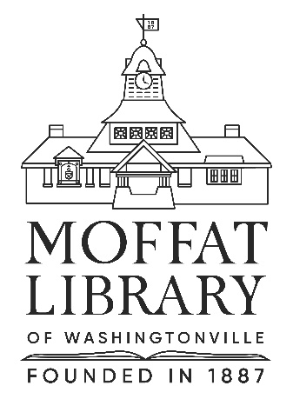

PART-TIME LIBRARY CIRCULATION CLERKS

The Moffat Library of Washingtonville, a public library located in the village of Washingtonville in Orange County, New York and serving a population of 25,000 residents, is seeking a dependable and friendly people to join our busy Circulation department.

HOURS:
Hours: Up to 20 hours/week. Includes daytime, evening shifts and weekends. The Library is open 7 days a week, Mondays through Thursdays: 10am-8pm; Fridays: 10am-6pm; Saturdays: 10am-5pm; & Sundays: 12-5pm. Must be willing to work on weekends.

RESPONSIBILITIES:
Typical Circulation Desk duties include: checking in and out library materials; issuing library cards; collecting fines/fees; assisting patrons in maintaining their library records; shelving library items; and a variety of general clerical duties.

REQUIREMENTS:
This position requires: ability to work with the public; strong customer service skills; the ability to juggle multiple demands; the ability to operate a computer and keyboard; the ability to speak, write and read English; the ability to express ideas clearly and accurately, both orally and in writing; to be attentive to detail; and to interact tactfully and courteously with patrons of all ages and staff. The candidate should also be able to do physical work such as standing, bending and lifting (up to 30 lbs).

MINIMUM QUALIFICATIONS:
Must have a high school diploma + one year of office or library experience. Spanish language fluency a plus.

Part-time positions are non-competitive OC Civil service positions.

Moffat Library of Washingtonville is an equal opportunity employer.

BENEFITS: NYS Retirement System (optional enrollment)

Please email cover letter and resume using the subject “Circulation Clerk Position – PART-TIME” to: Eleanor Doring, Circulation Supervisor: edoring@rcls.org / No phone calls please

Continuously accepting applications. Qualified applicants will be contacted for an interview. Starting hourly wage will be dependent upon experience.

Posted: 4/19/24

Moffat Library of Washingtonville
6 W Main Street
Washingtonville, NY 10992
https://moffatlibrary.org

